*Petclinic*

Front End Test Summary Report

Version *0.8*

*20/12/2018*

VERSION HISTORY

|  |  |  |  |  |  |
| --- | --- | --- | --- | --- | --- |
| **Version #** | **Implemented**  **By** | **Revision**  **Date** | **Approved**  **By** | **Approval**  **Date** | **Reason** |
| 0.8 | *Christopher Wesemael* | *20/12/2018* | *Chester Gardner* | *20/12/2018* | *Initial Structue outline* |
|  |  |  |  |  |  |
|  |  |  |  |  |  |
|  |  |  |  |  |  |

**Latest Version:** 20/12/2018

TABLE OF CONTENTS

1 Introduction 5

1.1 Purpose 5

2 Test Summary 5

3 Tests 5

4 Test Results 5

5 REccommended aCTIONS 6

Appendix A: Test Summary Report Approval 7

# 

# Introduction

## Purpose

This *PetClinic* Test Report provides a summary of the results of test performed as outlined within this document.

Specifically targeted at the non-functional aspects of the system

# 2 Test Summary

Testing of the non-functional aspects of the system, specifically aimed at the front-end components within the system. Selenium/JUnit primary technology used to achieve this.

**Project Name**: *Pet Clinic Testing Assignment*

**System Name**: *PetClinic*

**Version Number**: *1.0*

**Primary Testers**: *Celeste B., Jos*[é M. M. N.](https://en.wiktionary.org/wiki/%C3%A9)

# 3 Tests

# 4. Test Results

Tests were split between the different tabs found in the navigation bar, mainly focusing on adding and editing Owners. Most tests expected to pass did so successfully, which included adding valid entries and editing fields of pre-existing entries. A valid entry consists of fields with more than 2 characters for first name and last name, and only digits for the telephone field. The unsuccessful pass was expected as an invalid entry (name containing just one character) was used, shown in Figure 2. During the editing test, it was found that when a name longer than 20 characters an unexpected error was given which prevented saving the entry. Otherwise tests passed, as shown in Figure 1.

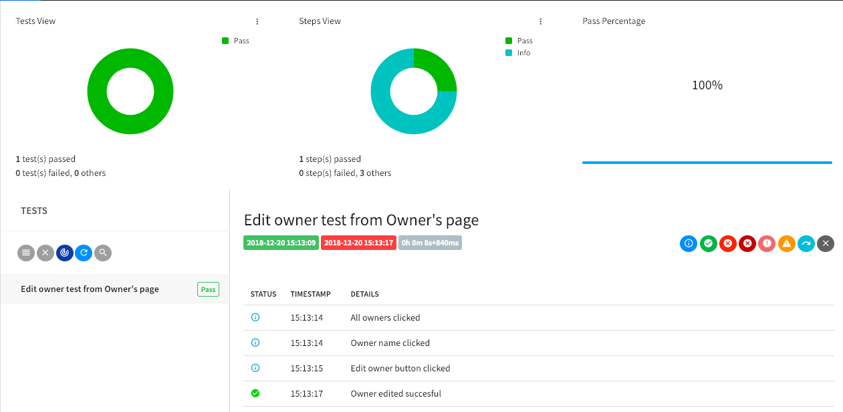

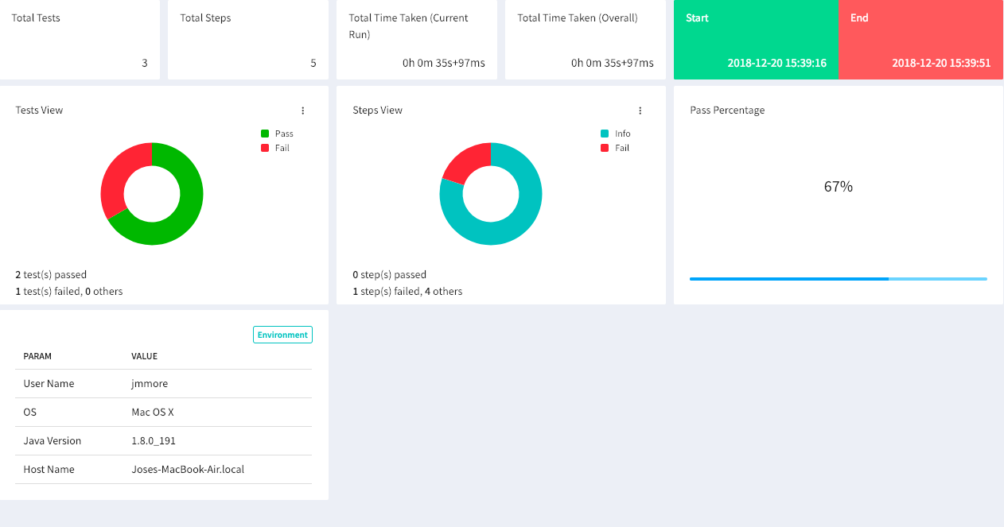

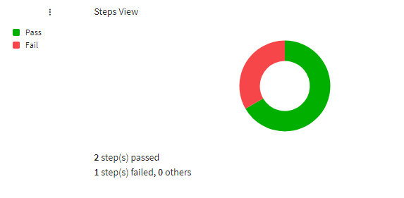

Figure 3 shows the proportion of tests that passed compared to failed displayed as a donut graph of testing adding veterinary records.

The ability to add veterinary records was tested. Tests on editing or deleting veterinary records were not yet run.

Referring to Figure 3, invalid first name, last name and type data were entered into the fields on the ./vets/add/ page. The “Add Vet” button should not have been active but it was, so invalid data was successfully submitted.

# Recommendations

Based on the test results, the unexpected failures have given cause for defect resolution before more retesting is conducted. A go live decision is not recommended.

Appendix A: Test Summary Report Approval

The undersigned acknowledge they have reviewed the *PetClinic* **Test Summary Report** and agree with the approach it presents. Changes to this **Test Summary Report** will be coordinated with and approved by the undersigned or their designated representatives.



|  |  |  |  |
| --- | --- | --- | --- |
| Signature: |  | Date: | 20/12/2018 |
| Print Name: | Chester Gardner |  |  |
| Title: | Consultant |  |  |
| Role: | Test Lead |  |  |